**NAME OF THE PROJECT**

**Online Banking System**

Prepared by

1 Vaishnavi Mantri 118A3025

2.Melvina Michael 118A3027

1. Introduction :

Online banking is a electronic payment System   that enables customers of a [bank](https://en.wikipedia.org/wiki/Bank) or other [financial institution](https://en.wikipedia.org/wiki/Financial_institution) to conduct a range of [financial transactions](https://en.wikipedia.org/wiki/Financial_transaction) through the financial institution's application. The online banking system will typically connect to or be part of the [core banking](https://en.wikipedia.org/wiki/Core_banking) system operated by a bank and is in contrast to branch banking which was the traditional way customers accessed banking services .Some banks operate as a direct bank (or “virtual bank”), where they rely completely on the application. Online banking application provides personal and corporate banking services offering features such as viewing transactions, obtaining statements, checking recent transactions, transferring money and making payments.

2. Need of the project:

* Online banking allows a user to conduct financial transactions via the Application.
* Consumers aren't required to visit a bank branch in order to complete most of their basic banking transactions.
* A customer needs a device and a bank card to register. Once registered, the consumer sets up a password to begin using the service.
* Online Banking services are available 24 hours a day and 365 days of the year.

3.Basic features:

* Login Page has some special features like forgot password and show password.
* It allows the admin to view all the customers' data Individually along with the transactions made.
* Even the Customers can view their transaction history .
* Customers can apply for loans and Fixed Deposit.

4.Technology Used (hardware and software):

The Application is developed using Java Programming Language

and SQL Statements. It is built using NetBeans

Version 8.0.2 and pgAdmin III.

5.Results (Screenshots):

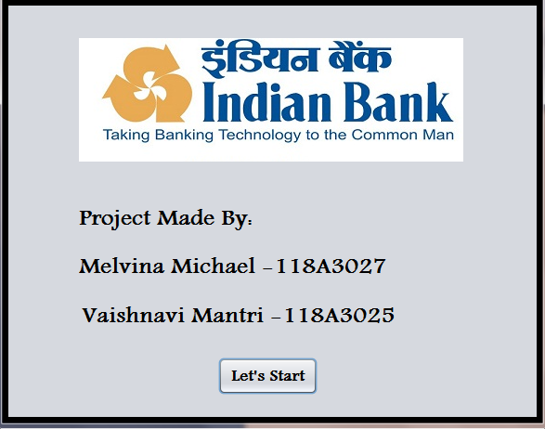

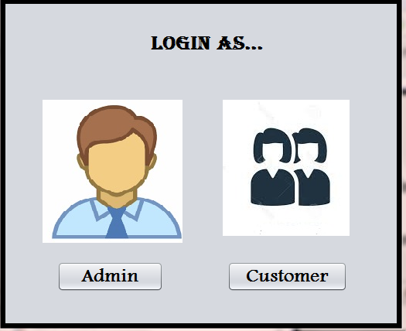

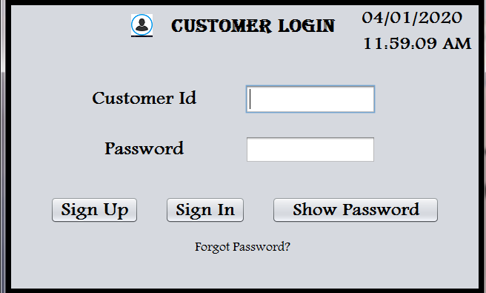

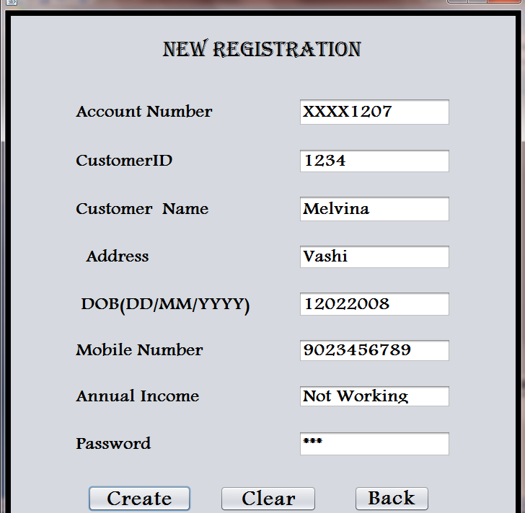

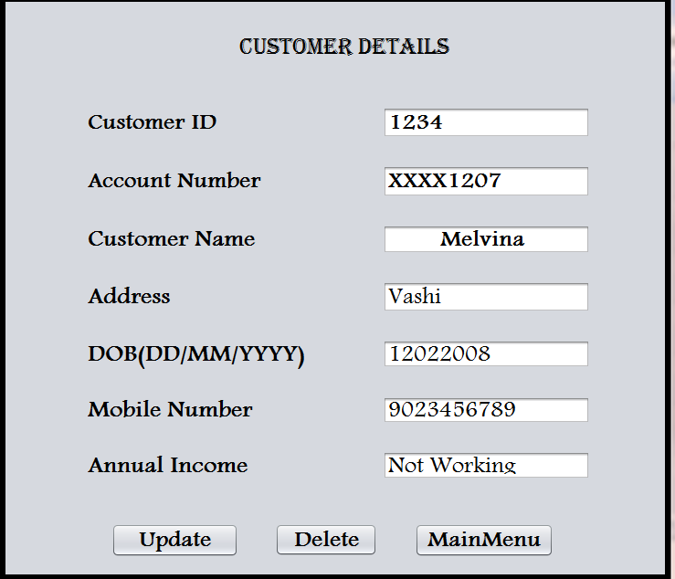

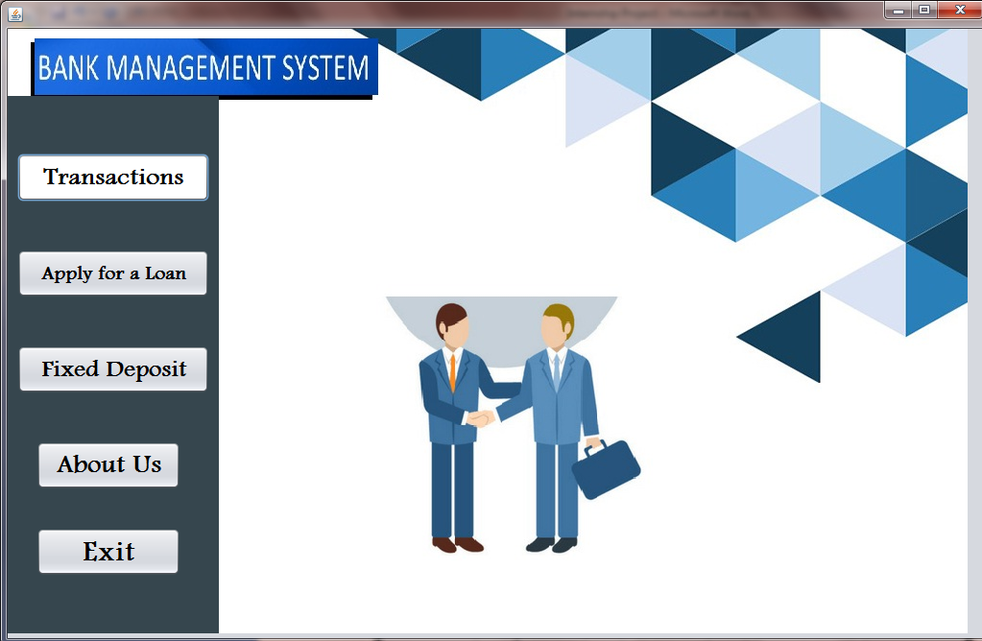

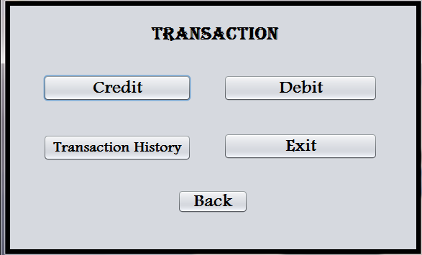

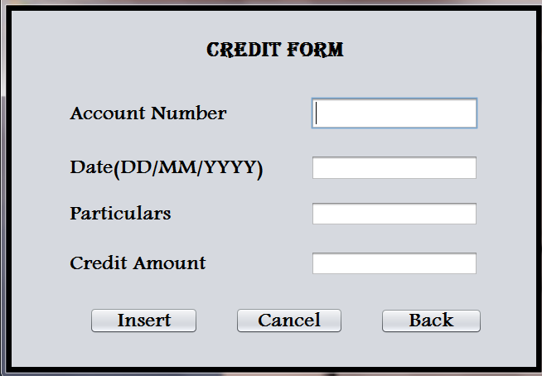

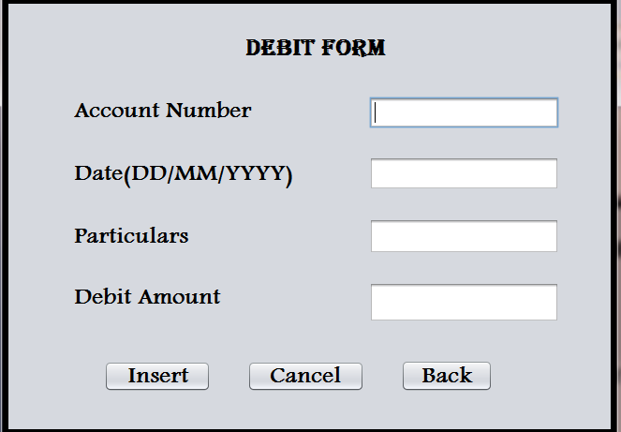

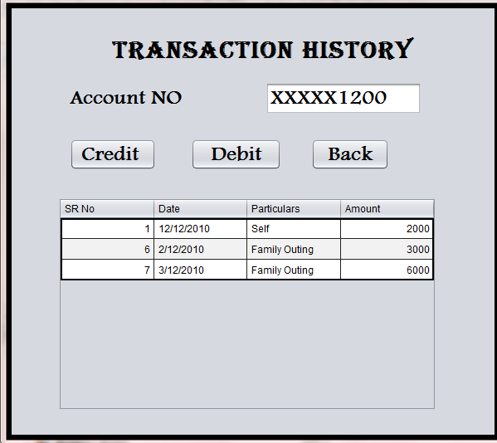

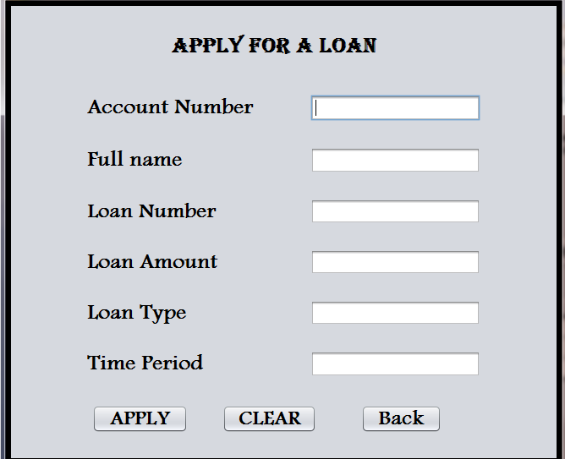

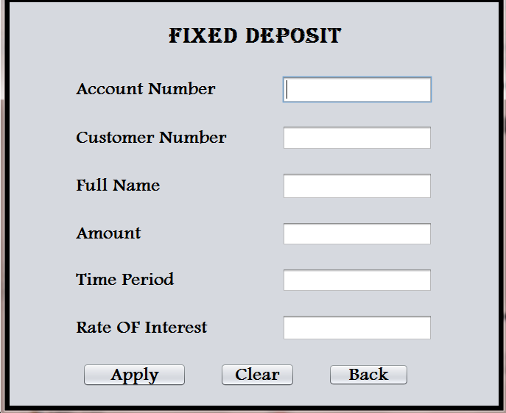

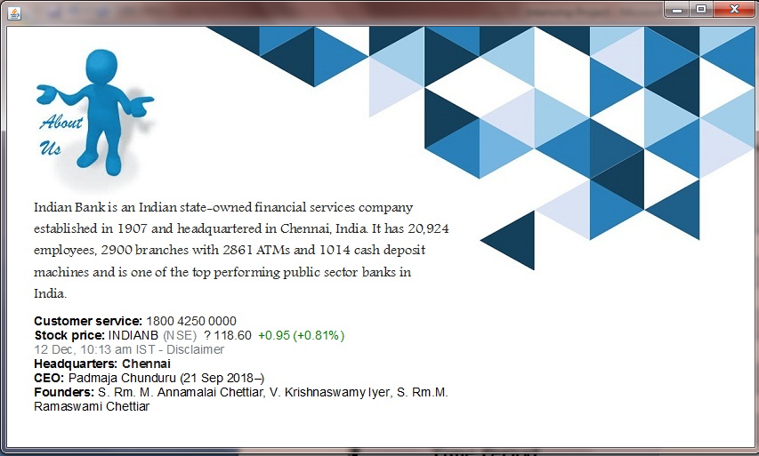

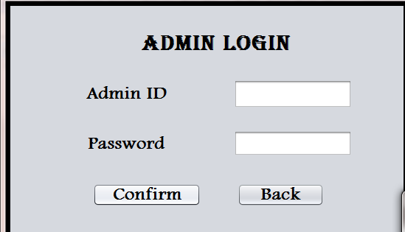



.z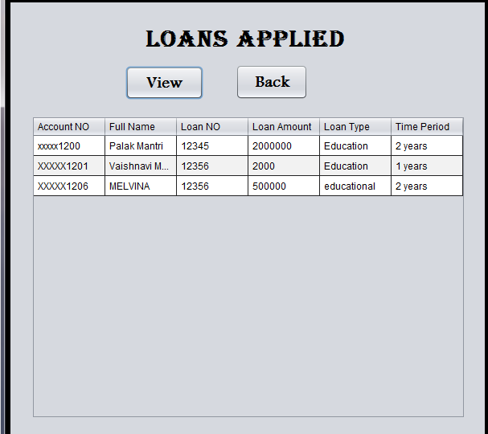

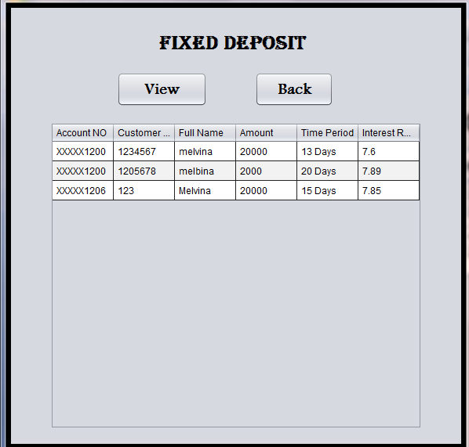

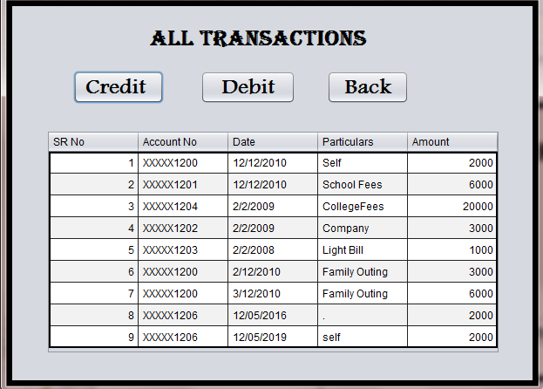

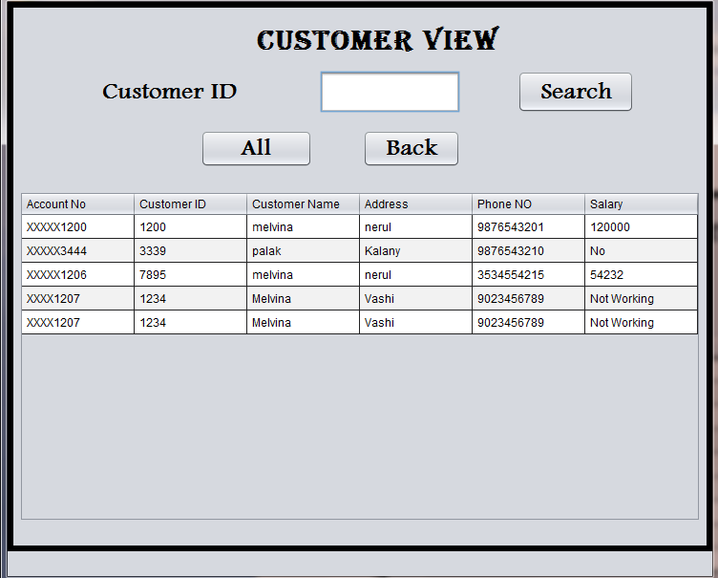

6.Conclusion:

Thus we have successfully build an online banking application using java and

SQL .For the Usefulness of the people working in the bank as well as for customers.